**When writing up a practical method, if appropriate, it is good practice to include a diagram to emphasize a point.**

**Q1.**

A student wants to calculate the density of the two objects shown in the figure below.

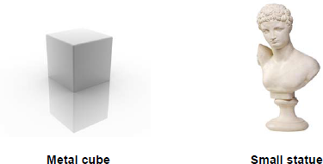

Describe the methods that the student should use to calculate the densities of the two objects.

**For this question you have to write 2 different methods. To make it clear to the examiner which method you are describing use subtitles.**

**Finding the density of a metal cube**

1. **Measure the length, width and height of the cube.**
2. **Times these values together to calculate the volume of the cube.**
3. **Find the mass of the cube by weighing it on a set of scales.**
4. **Use the equation density = mass ÷ volume to calculate the density of the cube.**
5. **Repeat the process at least 3 time to look for anomalous results and calculate the mean.**

**Finding the density of a small statue**

1. **Find the mass of the statue by weighing it on a set of scales.**
2. **Fill a displacement can so the water is at the same level as the spout (see diagram)**
3. **Place a measuring cylinder under the spout.**
4. **Carefully place the statue in the displacement can and collect the water.**
5. **Wait until the water has stopped coming out of the spout and read the value on the measuring cylinder. This is the volume.**
6. **Use the equation density = mass ÷ volume to calculate the density of the cube.**
7. **Repeat the process at least 3 time to look for anomalous results and calculate the mean.**

**(Total 6 marks)**

**When writing up a practical method, make sure your method includes any equipment you will use, and is set out so another person can follow the instructions to make the product.**

**Q1.**

The salt copper sulfate can be made by reacting copper carbonate with dilute sulfuric acid.

CuCO3 (s)   +   H2SO4 (aq)      CuSO4 (aq)   +   H2O (l)   +   CO2 (g)

Write a method that a student could use to prepare a pure, dry sample of copper sulphate.

* **Pour 25cm3 of dilute sulphuric acid into a beaker.**
* **Add a spatula of copper carbonate to the acid and stir.**
* **Continue to add copper carbonate until the fizzing stops.**
* **Filter the mixture to remove the excess copper carbonate.**
* **Pour the filtrate (cooper sulphate and water) into an evaporating dish.**
* **Heat gently to evaporate about half of the water.**
* **Leave the solution to crystallise in a warm place eg a sunny windowsill.**

**(Total 6 marks)**